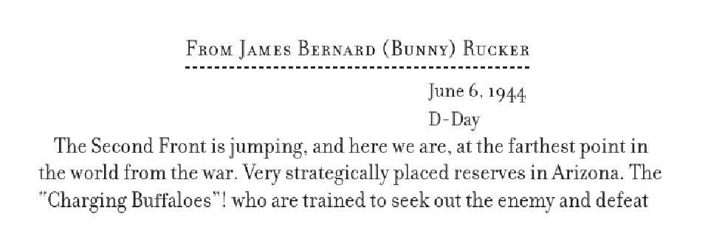
From: The Good Fight Continues. World War II Letters from the Abraham Lincoln Brigade. Ed. Peter Carroll, Mel Small, and Michael Nash. NY: NYU Press, 2006.
