ALBA Lesson Plan Template – Social Studies

Title: Pictorial Narratives From Children In War – Analyzing the Effect of War on Children
Subject: U.S. History, European History, World History
Grade(s): High School 9-12

Standards: CCSS.ELA-Literacy.RH.11-12.7

Key words/phrases: Rise of fascism, civil war, refugees, targeting civilians in war

Essential Questions: What can we learn about the effects of war on civilians by examining the artwork of children living in a war zone?

Synopsis: This lesson asks students to critically examine a group of drawings from children living in a war zone before, during, and after their lives have been upended.

Standard Alignment(s) Used: English Language Arts Common Core (reading historical sources)

Recommended Teacher Background: Teachers should watch the 10- or 40-minute introduction to the Spanish Civil War among the ALBA teacher resources.

Connections to other disciplines: English Language Arts – this lesson aligns well with several ELA Common Core standards such as: CCSS.ELA-LITERACY.RI.9-10.7: Analyze various accounts of a subject told in different mediums (e.g., a person's life story in both print and multimedia), determining which details are emphasized in each account.

Number of Class Periods: 1 to 2, 50-minute periods.

Standards:
CCSS.ELA-Literacy.RH.11-12.7 | Integrate and evaluate multiple sources of information presented in diverse formats and media (e.g., visually, quantitatively, as well as in words) in order to address a question or solve a problem.

Primary Sources:
- Children’s pictures from the ALBA archive (see Appendix 1-5)
Procedures
- Lead-In/Hook:
  - Ask students to contemplate how civilians are affected by living in a war zone. What happens to men, women, children, animals, homes during war? When did Americans last experience a war at home? What do we remember about war being fought on our own soil and its effects on the population?
  - Show students Picasso’s painting titled, “Guernica” and ask them to describe the details of the painting. What emotions are depicted in the painting? Inform students that “Guernica” was painted after an intense bombing of the northern Spanish (Basque) town of Guernica in 1937 during the Spanish Civil War by a squadron of Hitler’s Luftwaffe. It was the first ever large-scale bombing of a purely civilian target.
  - Inform students that Picasso’s painting may be the most famous image of the effect of war on civilians; however, many people constructed images during the Spanish Civil War, including children. Ask students what might be learned from examining artwork of children compared to a painter like Picasso? What are the advantages of seeing images of war through the eyes and hands of children?
- Pre-assessment and activation of prior knowledge: Review the terms fascism, Nazism, civil war, republic, refugees, agrarian, urban.

- Step by Step:
- After reviewing terms and questions above, break students up into groups of four or so. First, show them ONE of the documents in Appendix 1 (Give different images to different groups) and ask students to:
  - Take inventory: Working alone without collaborating, ask them to write down in list form everything they see in the image without overlooking a single detail (they don’t know what might be important later.)
  - Compare: Ask students to share their detailed list with other members of their small group, making note of details they may have overlooked. Some translation of Spanish words or phrases might be required.
  - Summarize: Ask students to work alone to write a three-sentence paragraph summarizing the “event” shown.
  - Compare: Have students share their paragraphs.
  - Hypothesize: Ask each group to discuss the artist’s reason for making the picture. What emotions might the artist be experiencing? What does the artist think is most important about the picture? How do these images compare to photographs or paintings such as “Guernica” in identifying the effect of war on civilians? What do you think is the approximate age of the artist? What bearing does this have on your analysis?
- Do the same activity with an image from Appendix 2 and Appendix 3. (If time is limited, the after-war images in Appendix 3 can be discussed in a large-group format. Two of the images have substantial written parts that provide clues, but may be more easily decipherable as a whole-class activity.)

- Closure: Teacher-Led Discussion – Discuss to what degree the images might be an important historical source, perhaps focusing on the idea of “social history” as a greater and greater component of a large historical narrative. How do the images change from before to after the war? What was life like for children living in Spain in the 1930s before the war? What assumptions can be made about the effects of war on civilians and especially children based on these images? Do they hold up to historical scrutiny, i.e. should analysis of such images be included in a historian’s account of the Spanish Civil War? Why or why not?

Differentiation/Enrichment:
- Advanced: Ask students to analyze the pictures in Appendix 5, noting that these images were made by students who left their homes and sometimes their country. What can we learn about what life was like outside Spain for refugee children by analyzing these images?

- Struggling: This lesson’s images can be presented with some additional information provided to students, including translation of text. (Further analyses of all of these images can be found at “They Still Draw Pictures” on the Abraham Lincoln Brigade Archives website.

Assessment:
As a question on a unit test (Between the Wars, The Rise of Fascism, World War II) students can analyze one of the pictures in Appendix 4 with all or some of the questions from section 3.a above. An additional question to ask as part of their analysis is, “During what part of the conflict (before, during, after) was this picture drawn?” and “What can you tell about the age of the author?”

As part of the assessment criteria, or as part of a student self-assessment, or as part of a post-test enrichment activity, use the analyses provided by, “They Still Draw Pictures” on the Abraham Lincoln Brigade Archives website.

Appendix 1: Images Before the War
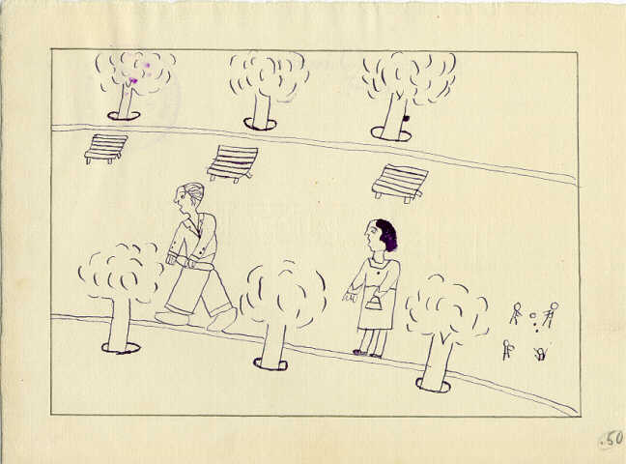

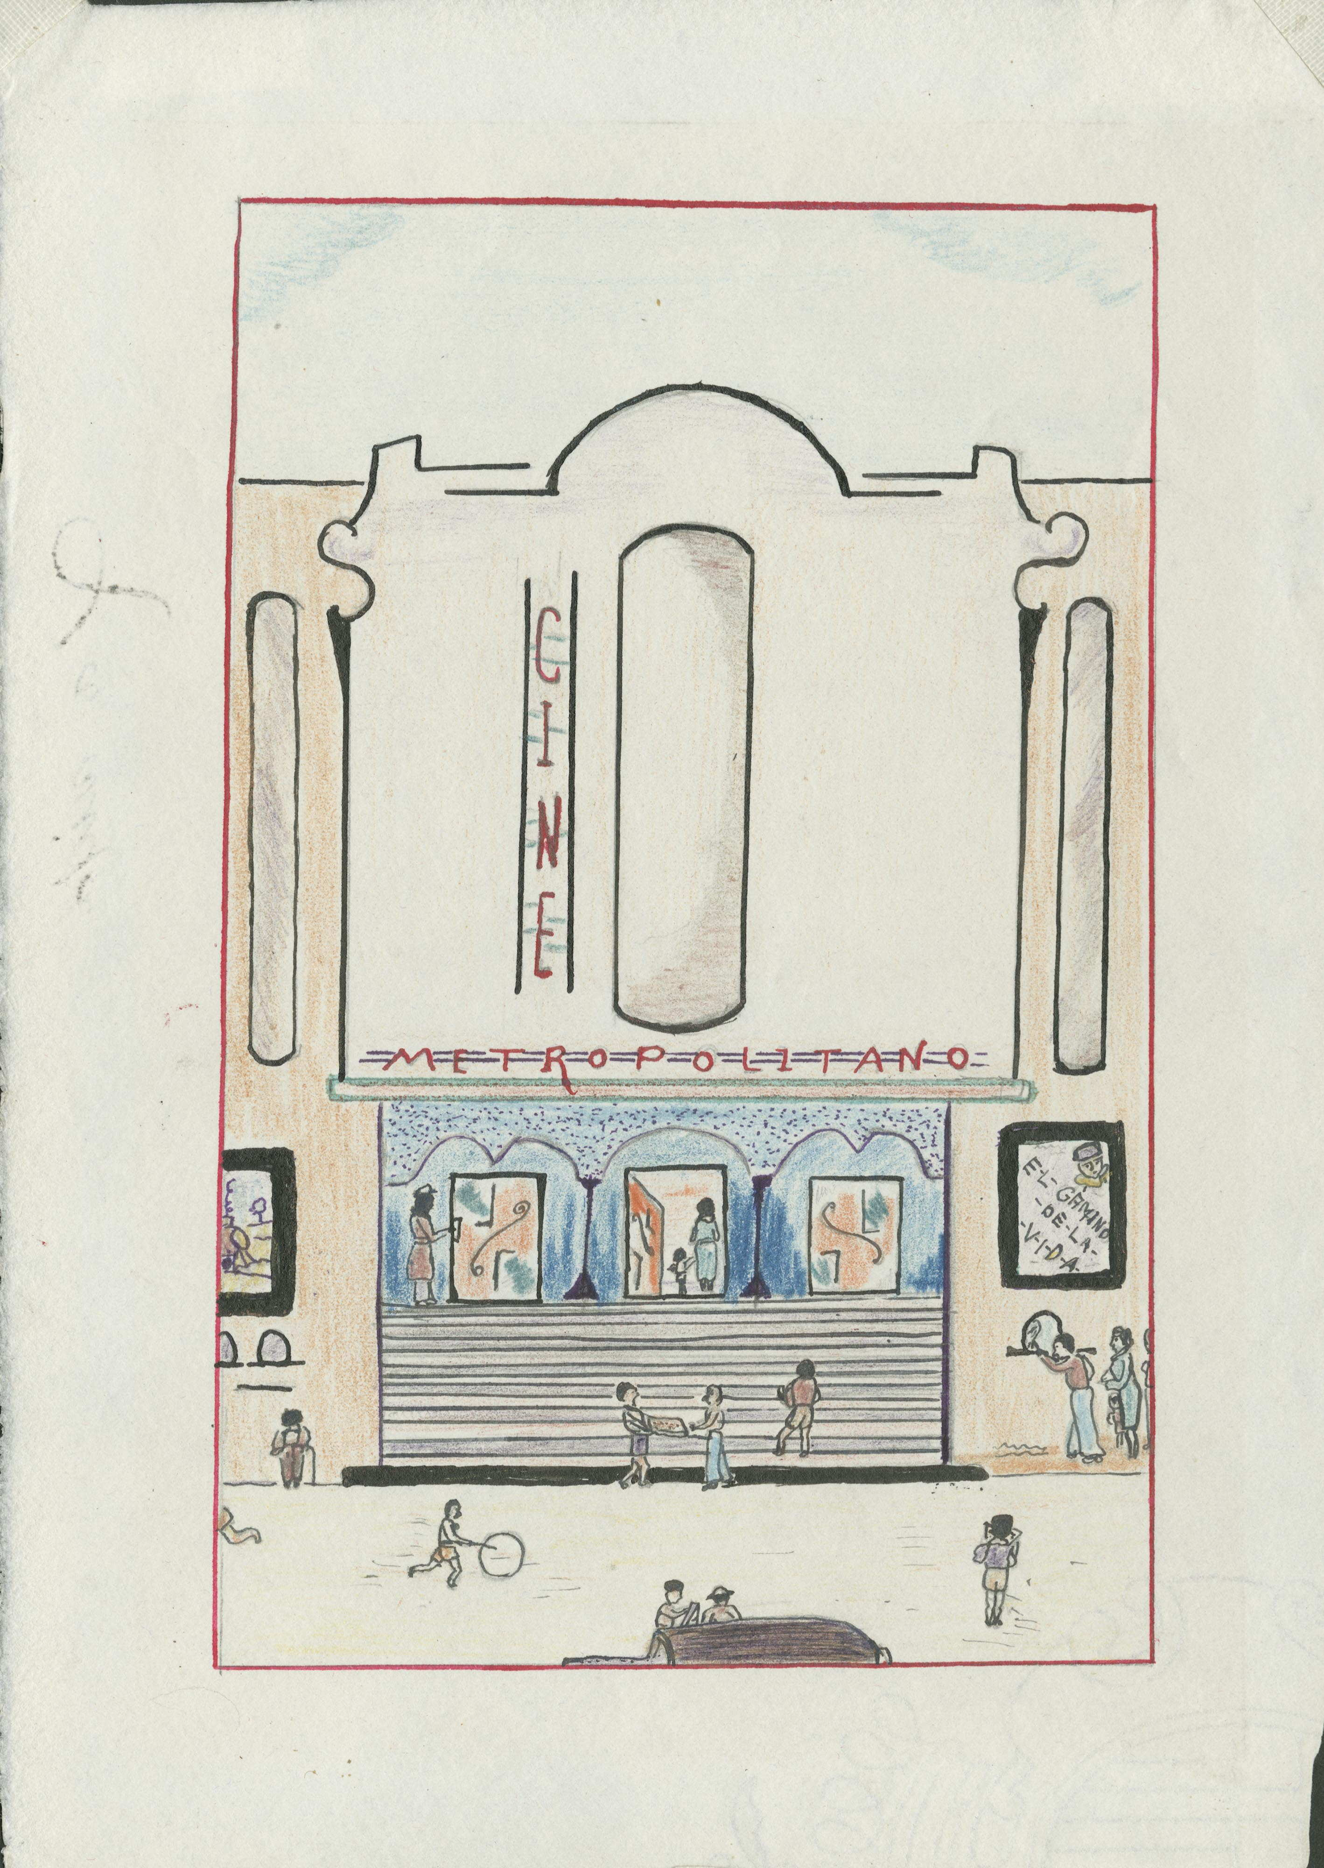

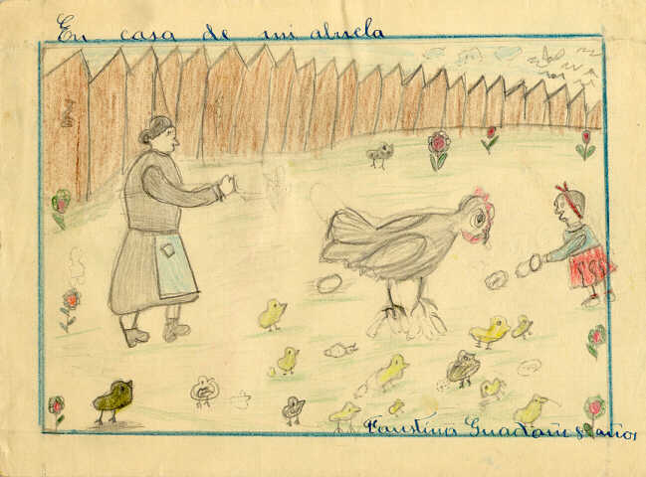

Appendix 2: Images During the War
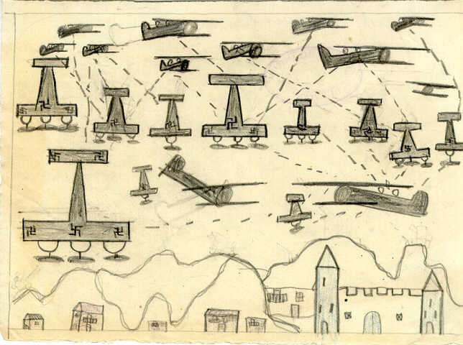

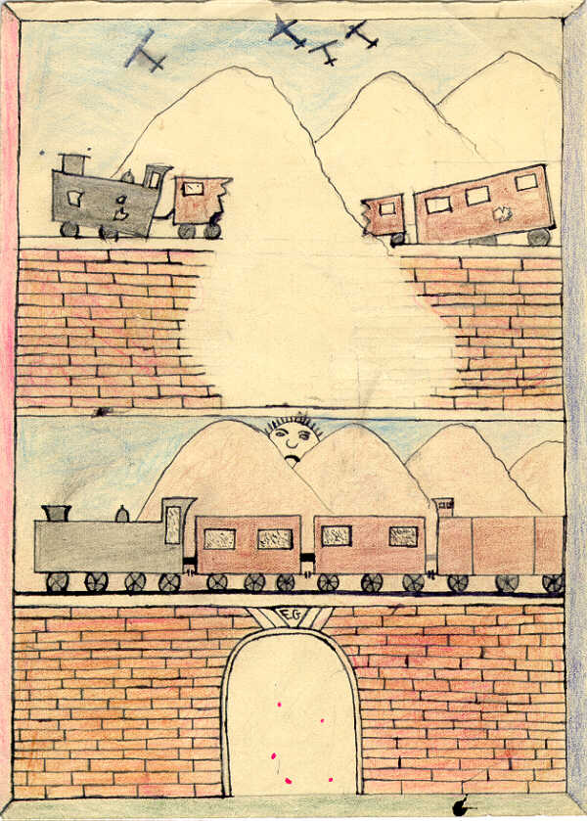

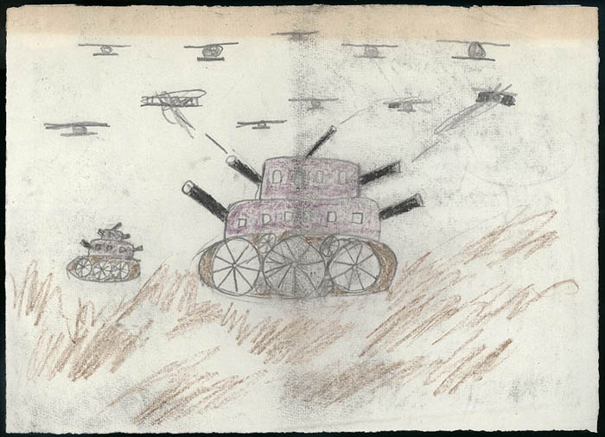

Appendix 3: Images After the War

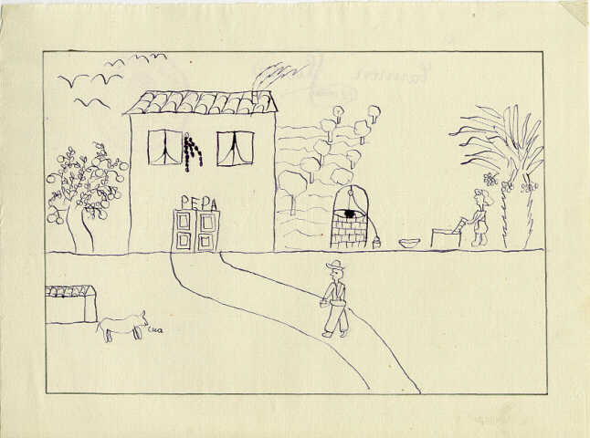

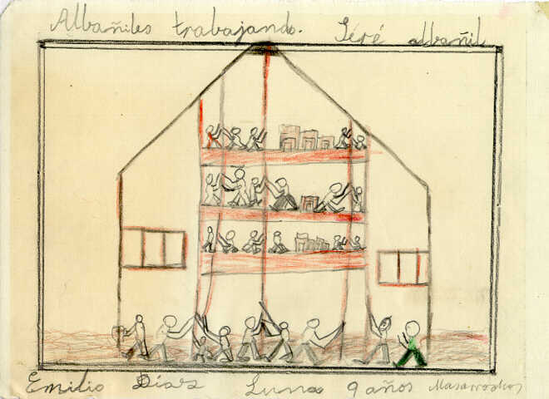

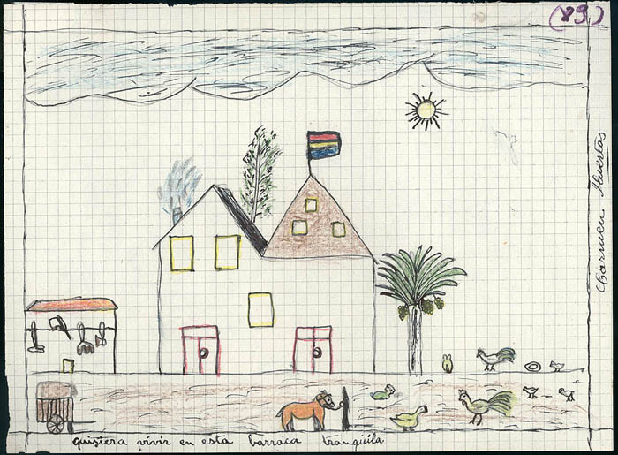

Appendix 4: Assessment Images

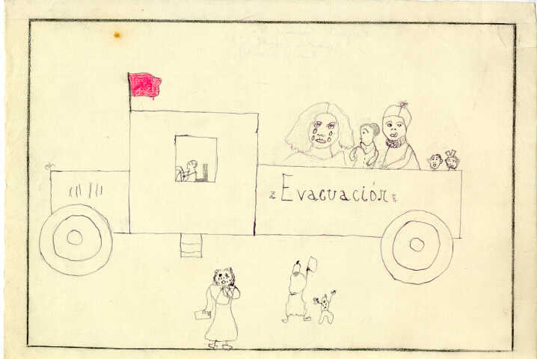

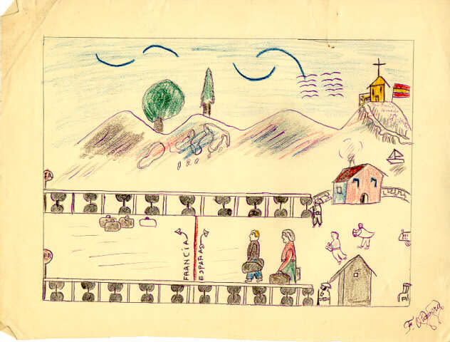

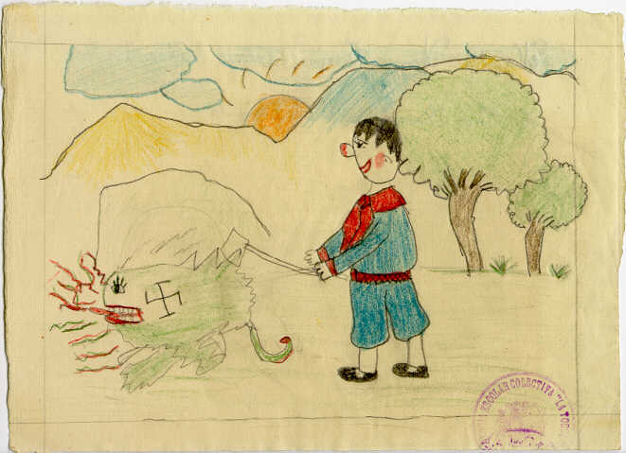

Appendix 5: Differentiation, Enrichment Images



