Lesson Plan Draft - June 5, 2014

Library of Congress – Teaching with Primary Sources (TPS)
Program Of the Collaborative for Educational Services
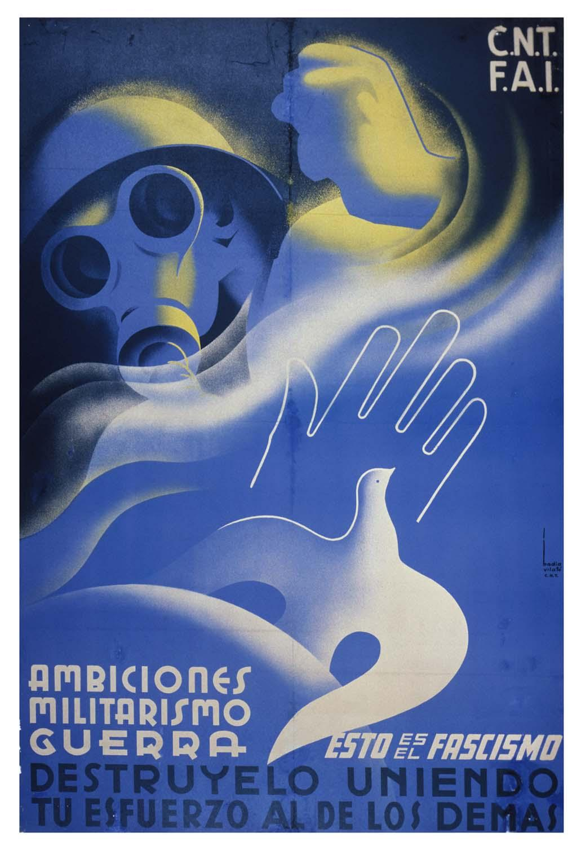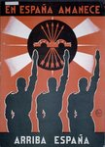 http://www.loc.gov/pictures/item/99615756/ http://www.loc.gov/pictures/item/99615707/
Ambiciones, Militarismo, & Guerra:
Propaganda Posters of the Spanish Civil War – 1936-1939
Lesson Grade Range: High School
Subject: U.S. and World History
Topic: The Spanish Civil War and the Use of Propaganda

Kwame Webster, Collaborative for Educational Services

Based on teachers’ draft lessons at a March, 2014 workshop co-sponsored by the Library of Congress TPS Program of the Collaborative for Educational Services and the Abraham Lincoln Brigade Archives http://www.alba-valb.org/.

Ambiciones, Militarismo, & Guerra: Propaganda Posters of the Spanish Civil War

Overview (Summary/Abstract)
In the Spanish Civil War (1936-1939), Nationalists (conservative and fascist) and Republican (liberal, socialist, anarchist, and communist) forces used propaganda to win the hearts and minds of Spanish citizens and to solicit international aid. The posters produced by both sides demonstrated the power of images. Introducing these posters will drive student inquiry and debate. From this lesson students will begin to recognize and question myriad propaganda techniques from the past and present. Through this inquiry, students will encounter question, including: What makes propaganda appealing? Why do propagandists use certain types of imagery? How is propaganda used in the United States? Students should also use this opportunity to compare and contrast propaganda with private sector attempts to convince the public of a variety of claims.
The wealth of primary source materials from the Library of Congress and Abraham Lincoln Brigade Archives makes this lesson dynamic for teachers and students. Students will present their analysis of a poster from the Spanish Civil War. Students will use the Primary Source Analysis tool to compare posters and present findings to the teacher and class.

Learning Objectives
Students will be able to:
- Identify the causes and impacts of the Spanish Civil War (1936-1939).
- Understand the rise and goals of totalitarian policies in Europe in the 20th Century.
- Define propaganda, explain its purposes, and describe its uses and methods.
- Identify significant historical questions of personal interest for further investigation through analysis of primary sources (especially from the Library of Congress).

Time Required
This lesson would take no more than two periods to complete. Assignments that are not completed will be assigned for homework (reflection and poster creation).

Recommended Grade Range
Modern World History or 20th Century U.S. History. Grades 8-12.
*Note: Sensitivity is required since some posters display blood, weapons, and potentially upsetting imagery, including victims of bombing, the Nazi swastika, and Soviet hammer and sickle.

Subject & Topic
  - World History – Spanish Civil War, and World War II
  - Political ideology: liberal, socialist, fascist, communist, anarchist, republican, Nazi, Soviet
  - Propaganda

PREPARATION

Materials

- Library of Congress Primary Source Analysis Tools
http://www.loc.gov/teachers/usingprimarysources/resources/Primary_Source_Analysis_Tool.pdf
- Spanish Civil War posters with translated captions.
  - Library of Congress: http://www.loc.gov/pictures/search/?sp=1&co=spcw&st=grid
  - University of California San Deigo: http://libraries.ucsd.edu/speccoll/visfront/vizindex.html
  - Abraham Lincoln Brigade: http://www.alba-valb.org/resources/lessons/the-spanish-civil-war-poster/introduction
- Laptop or other device to view posters for multiple groups. Or full-color printed posters

Extension:
- Poster board
- Markers, crayons, or colored pencils

Resources Used
(Full citations in Appendix. The suggested poster thumbnails and bibliographic information are at LoC.gov. Larger versions – and more selections – are online at other listed websites.)

(Republicans)
Padial, Antonio L. “Esto es el fascismo!”
http://www.loc.gov/pictures/item/99615795/
Summary: Four photographs, each is a scene depicting a horror of war; large swastika in foreground.

Monleón, Manuel. “C.N.T. Comite Nacional A.I.T. -- Oficina de Informacion y Propaganda.”
http://www.loc.gov/pictures/item/99615774/
Summary: Man with a hammer is about to strike a snake, the symbol of fascism.

(Nationalists)
Servicio Nacional de Propaganda. “Gloria - Franco - España.”
http://www.loc.gov/pictures/item/99615754/
Summary: Soldier's face, with laurel leaves in helmet and flags below.

Hohenleiter. “Falange os llama, ahora o nunca.”
http://www.loc.gov/pictures/item/99615769/
Summary: Soldier, with a Falange symbol on his shirt, is waving one hand and has a weapon in the other.

PROCEDURE

Description of Procedure

Steps:
Teachers will analyze two posters (one Nationalist and one Republican) from the Spanish Civil War using the Primary Source Analysis Tool from the Library of Congress. Students will later use that tool to evaluate the message of other posters. If students are new to the Library of Congress Primary Source Analysis Tool, the teacher will need to carefully model its use and guide students to learn to use it. The main purpose of the tool in this case is for students to identify and cultivate questions about the poster. In turn, student questions should shape the subsequent investigation of the Spanish Civil War.

The experience of analyzing these poster will clearly change significantly, depending on how much students have already studied European political movements of the period. At the start of such study, the posters can help raise basic questions about the different ideologies and events associated with them. Placed within or at the end of a unit on the period, students can begin to raise questions about the fates of the various movements and about the role of propaganda in the spread of ideology.

If the teacher chooses to lead a lesson on the context for the Spanish Civil War prior to analysis of the first poster, the presentation could span the years before and after that war. In this short introduction the teacher should characterize Spain via:
-Culture (the Church, military, ideology, and effects of gender)
-Identify world events (Depression, Rise of fascism, and Isolationism in Western powers)

Teachers should introduce the question: How does one side in a conflict persuade people of the justness of their cause? What are the purposes and techniques of propaganda?

Pairs of students now receive one example of each type of poster; pro-nationalist or pro-republican. Two of four of the same posters will be given to each student. The teacher will select pairs to explain their posters to the class. Their explanation should include the stated message of each poster and all relevant symbols. The pair will complete a primary analysis tool for both posters they receive. As the teacher circles the class, they can begin to group students for the second part of the lesson and provide feedback on students explanations. As the select pairs present, the teacher might add to the analysis of the posters, building off the original pair’s inquiry as well as answering any questions.

Below are potential questions to introduce to guide inquiry:

Observe (Identify & Note Details) | Reflect (Generate & Test Hypothesis) | Question (Ask Questions)
What do you notice first?  What people and objects are shown?  What other details can you see?  Identify: symbols, audience  What is missing from the poster?  Which side created the poster?  What emotions does the poster appeal to? | What do images portray?  What story do the images tell?  Who do the posters aim to reach?  Who created the posters?  What is the expected change the artists hopes for?  How does this poster appeal to different socio-economic groups? | What questions do the posters raise for you?  How do these posters compare with political appeals from today? What media are used today?  How does the poster address the central question?  When is it morally right as a nation or as an individual to get involved?

The students will then be split up into groups of 4 (the teacher should have already selected these groups). The groups of students will go to a computer and proceed to the ALBA or UCSD website. The students will be instructed to go the posters section of the website and choose a poster. The students, still in their groups, will spend a few minutes discussing the poster their group selected and completing an additional Primary Source Analysis tool if necessary.

With the poster:
- Describe what is happening in the picture.
- Identify all symbols used and explain what you think they mean and why.
- What emotions are evoked? Which side (Nationalist or Republican) created that poster?
- Who are the posters trying to reach? What likely effect would it have?
- Are there any hidden message in the poster?
- Compare and contrast the posters to any earlier studies of advertising or propaganda (such as magazine ads, or WWI posters).
- Identify questions in each category:
  - Observe: Just the facts. Describe what you see without making inferences or giving interpretation.
  - Reflect: Question should address the poster specifically: What is going on? What is the context? What do symbols mean? What is the message? Are there hidden messages?
  - Question: What do you want to know more about?

Presentations:
Students will share their poster analysis with the class. Each team will give their poster choice to the teacher to project through a projection machine or on a smart board. That group will lead class analysis of the poster.

Differentiating the lesson. (Based on student capability.)

This lesson starts with an introduction to the Spanish Civil War then moves on to a discussion of propaganda during that conflict. The bunk of the lesson is on analyzing the posters with an increasing release of direct support from the teacher. Students who need more support can continue working with the teacher towards greater understanding. Students who demonstrate a higher level of mastery can be released to review posters on their own or in small groups
.
Another way to differentiate is the length of the final analysis. Some student might be able to just answer the eight questions and others could write more than a page for the analysis.

Finally, the extension component of the lesson has students making their own poster. If students work quickly through the final assignment then they can begin the extension.

Other ways to differentiate:
-Teachers can help students compare and contrast to earlier units on dictators.
-Connect to in-depth examination of WWII propaganda (Allied and Axis powers).
-Connect to situations of conflict in the world today. Identify tools of visual persuasion from those conflicts. Be sensitive that this step may include some students’ home countries.

Extension Ideas

Individual Assignment:
- Students will be prompted to select a completely different poster individually (the teacher might need to facilitate selection to avoid students choosing the same one). Individually students will offer the same analysis of the poster, using the 6 questions as a guideline but will submit a 1-page analysis of the poster.

- Students will draw their own late 1930s style propaganda posters. Pick an appropriate topic you feel strongly about and decide your: stance, audience, and message.

Posters should be detailed and students should be able to clearly describe the symbols used and the message.

- Student questions surfacing from the Primary Source Analysis tool should shape the subsequent investigation of the Spanish Civil War. U.S. History courses may wish to delve deeper into the role of the nearly 3,000 American international volunteers of the Abraham Lincoln Brigade.

EVALUATION

Assessment
To assess student knowledge about the Spanish Civil War and the role of ideology in the mid-20th Century, as well as the purpose and techniques of propaganda, students in groups of four will present a poster to the class. Presentations should be assessed based on quality analysis and use of primary sources as evidence, and quality of presentation.

Competencies | CCSS | Criteria for Quality Checklist
Analysis of Propaganda | RS.11-12.1 | - Clearly identifies the various political positions.  - Identifies and explains relevant and meaningful symbols.  - Explains tools of propaganda employed.
Analysis of Primary Sources | RS.11-12.5 | - Makes a logical argument.  - Supports argument with several specific details from the posters.  - Raises significant, relevant, interesting questions.
Quality of Presentation | SL.11-12.1 | - Well-organized, clear, coherent.  - Visual aids are relevant, clear, effectively labeled and explained.

Massachusetts State History Framework & Common Core State Standards Addressed

U.S. History in the 20th Century Standards
USII.14 Explain the strength of American isolationism after World War I and analyze its impact on U.S. foreign policy. (H)
USII.15 Analyze how German aggression in Europe and Japanese aggression in Asia contributed to the start of World War II and summarise the major battles and events of the war. On a map of the world, locate the Allied powers (Britain, France, the Soviet Union, and the United States) and Axis powers (Germany, Italy, and Japan). (H, G)

Modern World History Standards
WHII.21 Describe the rise and goals of totalitarianism in Italy, Germany, and the Soviet Union, and analyze the policies and ideas of Mussolini, Hitler, Lenin, and Stalin. (H)

WHII.22 Summarize the consequences of Soviet communism to 1945. (H, E)
- the establishment of a one-party dictatorship under Lenin
- the suffering in the Soviet Union caused by Stalin’s policies of collectivization of agriculture and breakneck industrialization
- the destruction of individual rights and th use of mass terror against the population, the use of terror against internal enemies, and the destruction of individual rights
- the Soviet Union’s emergence as in industrial power

WHII.23 Describe the German, Italian, and Japanese drives for empire in the 1930s. (H)
- Italy’s invasion of Ethiopia in 1935
- the Japanese invasion of China and the Rape of Nanking
- Germany’s militarization of the Rhineland, annexation of Austria, and aggression against Czechoslovakia, the Stalin-Hitler Pact of 1939, and the German attack Poland

Common Core State Standards

Anchor Standards for Reading in English Language Arts & Literacy in History/Social Studies

Craft and Structure: Evaluate different sources on the same topic (event, issue). Assess claims, reasoning and evidence.

Integration of knowledge and Ideas: Analyze how the posters affect the meaning of their message and how
the poster is presented.

RS.11-12.5 Analyze in detail how a complex primary source is structured, including how key sentences, paragraphs, and larger portions of the text contribute to the whole.

RS.11-12.6 Evaluate authors’ differing points of view on the same historical event or issue by assessing the authors’ claims, reasoning, and evidence.

RS.11-12.1 Cite specific textual evidence to support analysis of primary and secondary sources, connecting insights gained from specific details to an understanding of the text as a whole.

RS.11-12.3 Evaluate various explanations for actions or events and determine which explanation best accords with textual evidence, acknowledging where the text leaves matters uncertain.

SL.11-12.1 Initiate and participate effectively in a range of collaborative discussions (one-on-one,
in groups, and teacher-led) with diverse partners on grades 11–12 topics, texts, and
issues, building on others’ ideas and expressing their own clearly and persuasively.
a. Come to discussions prepared, having read and researched material under
study; explicitly draw on that preparation by referring to evidence from texts and
other research on the topic or issue to stimulate a thoughtful, well-reasoned
exchange of ideas.
b. Work with peers to promote civil, democratic discussions and decision-making,
set clear goals and deadlines, and establish individual roles as needed.
c. Propel conversations by posing and responding to questions that probe
reasoning and evidence; ensure a hearing for a full range of positions on a topic
or issue; clarify, verify, or challenge ideas and conclusions; and promote
divergent and creative perspectives.
d. Respond thoughtfully to diverse perspectives; synthesize comments, claims, and
evidence made on all sides of an issue; resolve contradictions when possible;
and determine what additional information or research is required to deepen the
investigation or complete the task.

Appendix
(Republicans)
Padial, Antonio L. “Esto es el fascismo!” Poster. Socorro Rojo Internacional: Spain, 1936-1939.
- Summary: “This is fascism!” Four photographs, each is a scene depicting a horror of war; large swastika in foreground.

Monleón, Manuel. “C.N.T. Comite Nacional A.I.T. -- Oficina de Informacion y Propaganda.” Confederacion Nacional Trabajo (C.N.T.): Spain, 1936-1939.
- Summary: “National Confederation of Workers.” Man with a hammer is about to strike a snake, the symbol of fascism. CNT was a Spanish anarchist union. AIT was an international association of anarchist workers.

(Nationalists)
Servicio Nacional de Propaganda. “Gloria - Franco - España.” Servicio Nacional de Propaganda” Sevilla, Spain, 1939.
- Summary: Soldier's face, with laurel leaves in helmet and flags below.

Hohenleiter. “Falange os llama, ahora o nunca.” Falange Espanola: Spain, 1936-1939.
- Summary: “Calling all Falangists. It’s now or never.” Soldier, with a Falange symbol on his shirt, is waving one hand and has a weapon in the other.

